**Modern Control Theory Assignment 1**

**Extended Kalman Filter**

**Algorithm** (Refer to the code files attached)

The following algorithm was used to estimate the states using extended Kalman Filter.

1. Define all the function variables and parameters.

Input variables : 𝐹𝑎, 𝐹𝑠𝑐 and Output variables : 𝐶𝑟𝑐 , 𝑂𝑑, 𝑇𝑟𝑔

Measured variables 𝑇𝑟𝑔 and 𝑇𝑟𝑔, 𝐶𝑟𝑐

1. Assume the initial values of X0, P0, Q and R.
2. Using the given system of equations find out the Jacobian with respect to the states(X) and the inputs (U).
3. **PREDICTION**: Use an ODE solver in MATLAB to solve the simultaneous system of equations using an initial estimate at time t=0 as (X0) to find out the predicted state value X1/0. ODE15s was used for this case.
4. Evaluate the Jacobian at X0 to find out the continuous parameters. (Ac and Bc)
5. Convert continuous system to discrete system. Using either c2d function or expm function.
6. Calculate P1/0 using initial P0 and Q. (Ad*P0*Ad’ + Q)
7. **CORRECTION**: Calculate the Kalman Filter Gain – K. (P1/0*C’*(C*P1/0*C’ + R)^-1.
8. Update P to P1/1 using K. ( (I-K*C)^-1 *P1/0)
9. Update the state estimated (X1/1) using the measurement and the Kalman Gain.  
   X1/1 = X1/0 + K*(Y – C* X1/0)
10. Go back to Step 3, and give X1/1 as the initial state to proceed to the next time step.
11. Change the parameters of the system and plot appropriate graphs.
12. Repeat the same for Case 2 where 2 values are measured.

CASE 2: Two measured output (only Trg is measuerd) Variation of Q

Parameters Set 1

|  |  |  |  |  |  |  |  |  |
| --- | --- | --- | --- | --- | --- | --- | --- | --- |
| X0 | Q | | | R | | P0 | | |
| 0.00385 | 3.85 | 0 | 0 | 1 | 0 | 0.0044 | 0.004 | 0.0032 |
| 0.00472 | 0 | 4.72 | 0 | 0 | 1 | 0.004 | 0.0048 | 0.0048 |
| 972.1 | 0 | 0 | 972100 |  |  | 0.0032 | 0.0048 | 200.0056 |

Parameters Set 2

|  |  |  |  |  |  |  |  |  |
| --- | --- | --- | --- | --- | --- | --- | --- | --- |
| X0 | Q | | | R | | P0 | | |
| 0.00385 | 0.00385 | 0 | 0 | 1 | 0 | 0.0044 | 0.004 | 0.0032 |
| 0.00472 | 0 | 0.00472 | 0 | 0 | 1 | 0.004 | 0.0048 | 0.0048 |
| 972.1 | 0 | 0 | 972.1 |  |  | 0.0032 | 0.0048 | 200.0056 |

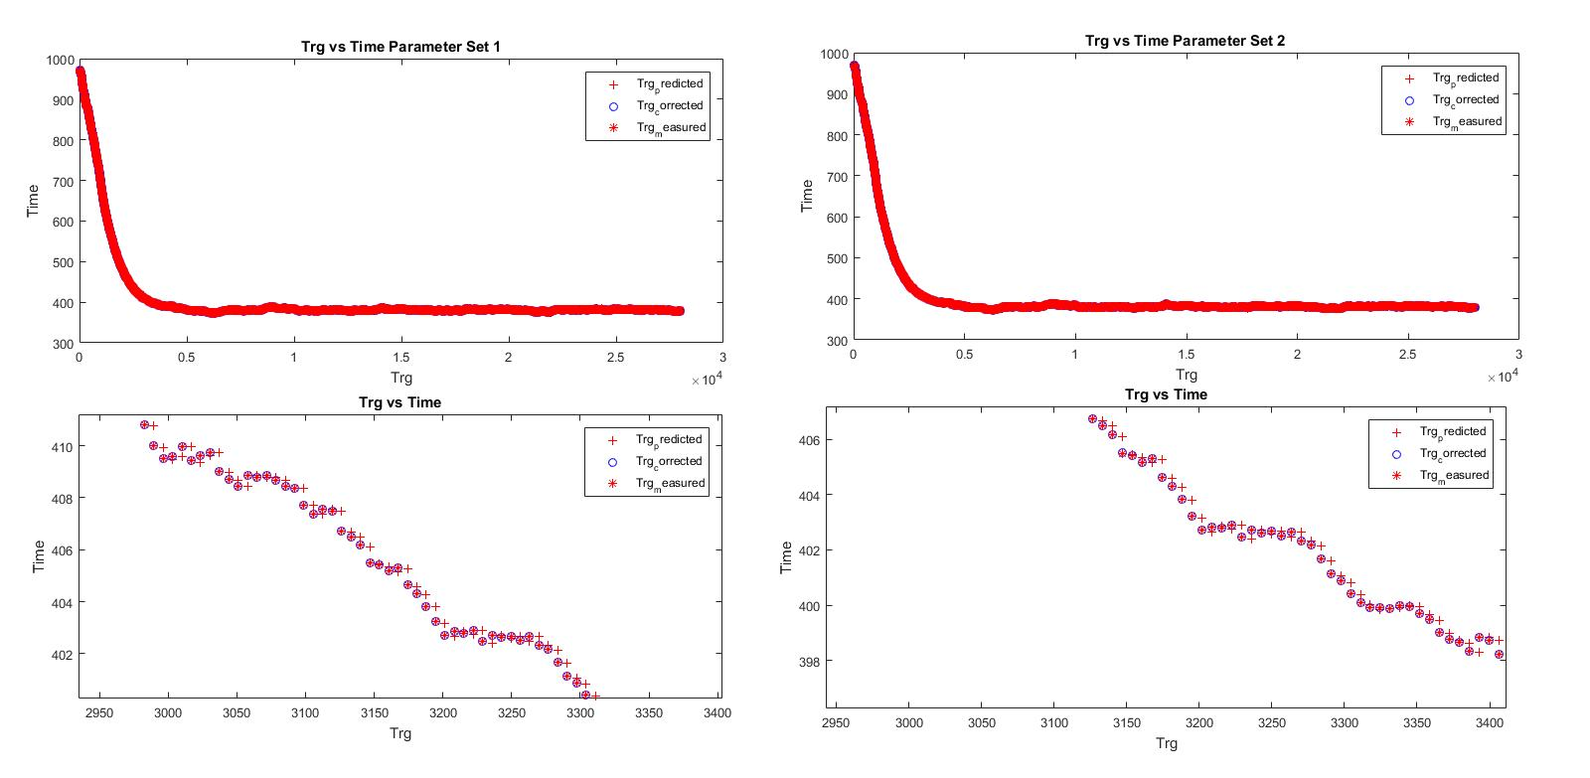

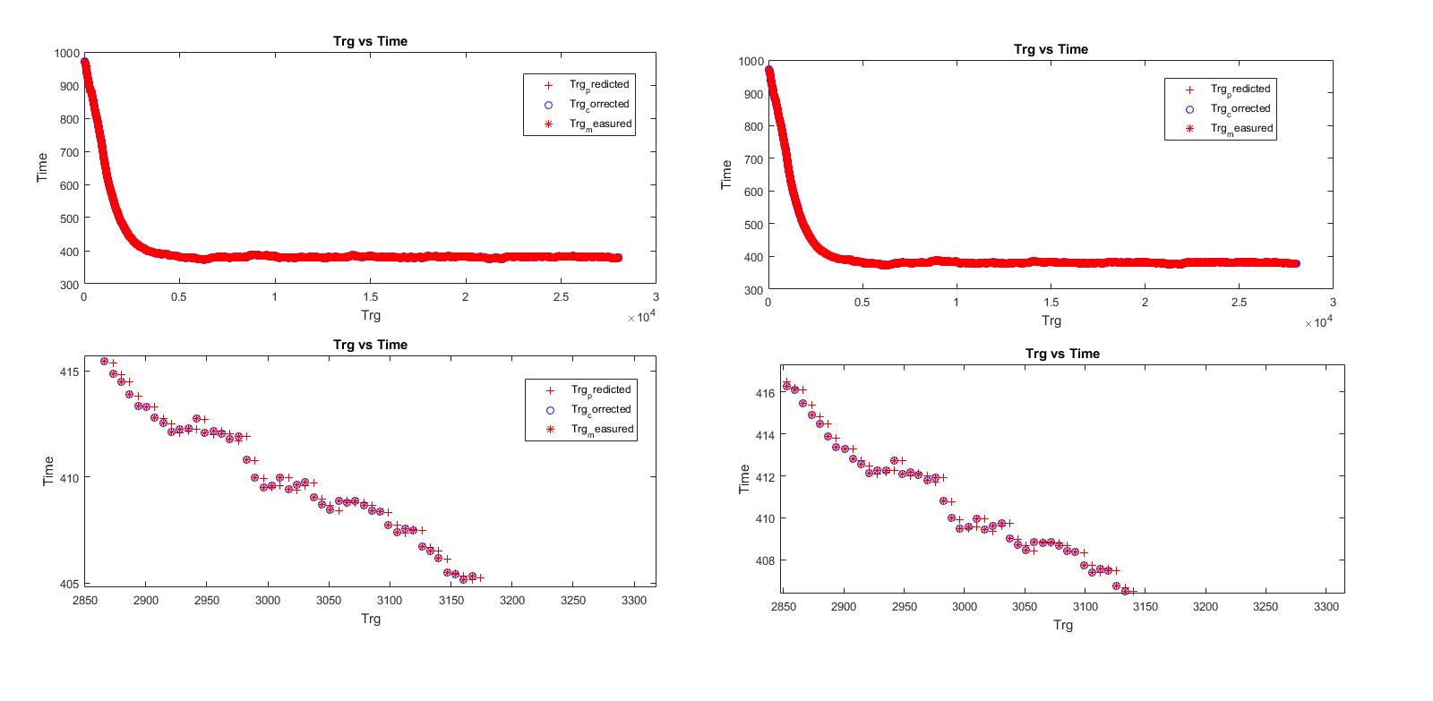Case 1 and Case 2 State Estimation Comparison

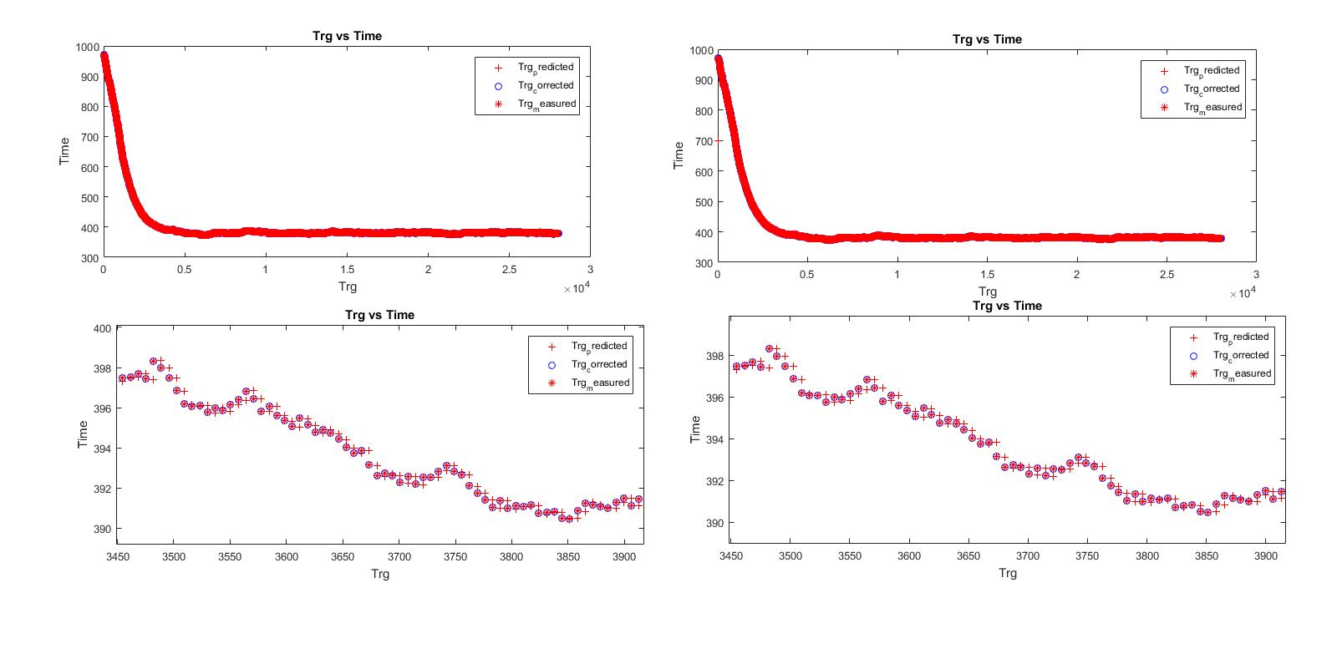Variation of X0 keeping all other parameters constant.

|  |  |
| --- | --- |
| X0 Set 1 | X0 Set 2 |
| 0.005 | 0.00385 |
| 0.005 | 0.00472 |
| 700 | 972.1 |

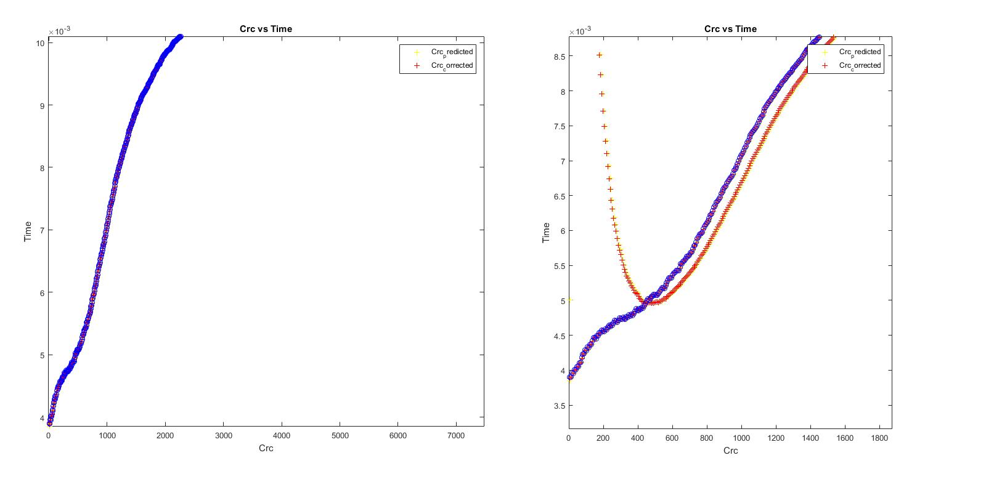Variation with P0

|  |  |  |  |  |  |
| --- | --- | --- | --- | --- | --- |
| P0 Set 1 | | | P0 Set 2 | | |
| 0.0044 | 0.004 | 0.0032 | 0.36 | 0.52 | 0.36 |
| 0.004 | 0.0048 | 0.0048 | 0.52 | 0.88 | 0.68 |
| 0.0032 | 0.0048 | 200.0056 | 0.36 | 0.68 | 200.56 |

